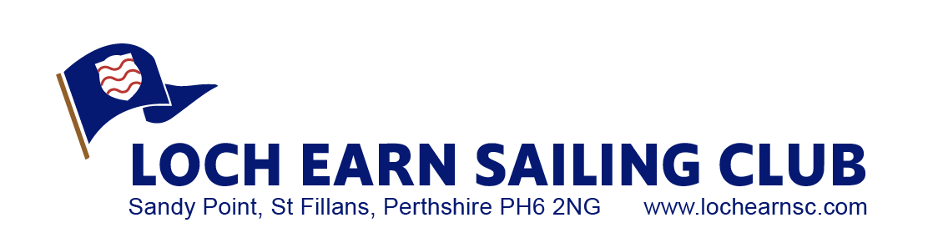

Entry Form

Name and address of Helm

Name of Crew

Name and Number of Boat

Entry Fee payable by Bacs £30 to Bobby Salmond

A/c number 00194119 sort code 83-17-20

Tent or Motor home fee per night £5.00

Please email back to salmond@hotmail.co.uk